Persistence decision and reasoning:

ERD:

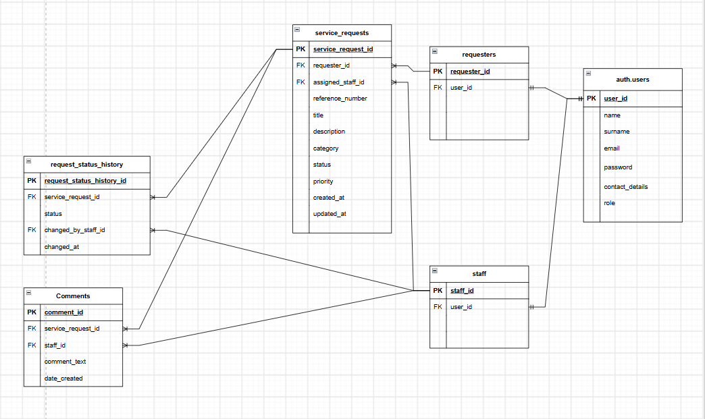

Persistence-Justification Writeup
Structure
The central identity table is auth.users, which is managed by Supabase authentication. Application-specific user information is represented through the requesters and staff tables, which reference auth.users using user_id.
The main transactional entity is service_requests, which stores each service request and references both the requester who submitted it and, where applicable, the staff member currently assigned to it.
The model also includes Comments for communication associated with a service request and request_status_history for maintaining a chronological record of status changes.
The main tables shown in the ERD are therefore:
- auth.users — Supabase authentication identity
- requesters — requester-specific user information
- staff — staff-specific user information
- service_requests — central service-request transaction
- Comments — comments associated with service requests
- request_status_history — historical record of request-status changes
All attributes are known and structured in advance. The relationships between these entities are also well defined, making a relational database appropriate rather than a document-oriented or schema-less persistence model.

Relationships
The ERD defines the following relationships:
- Users 1:1 Requesters — a user may have a requester record where the user performs the requester role.
- Users 1:1 Staff — a user may have a staff record where the user performs the staff role.
- Requesters 1:* Service Requests — a requester can submit multiple service requests.
- Staff 1:* Service Requests — a staff member can be assigned to multiple service requests.
- Service Requests 1:* Comments — a service request can contain multiple comments.
- Service Requests 1:* Request Status History — a service request can have multiple historical status-change records.
- Staff 1:* Comments — a staff member can create multiple comments.
- Staff 1:* Request Status History — a staff member can perform multiple status changes.
The relationships are implemented using foreign keys such as requester_id, assigned_staff_id, user_id, service_request_id and staff_id.
This structure provides explicit relational integrity because references between tables can be enforced by the database rather than relying entirely on application code.

Access Patterns
Requester:
A requester primarily needs to:
- Insert a new service request.
- Select their own service requests using requester_id.
- View the current status, priority, category and other request information.
- View comments associated with their requests.
- View the historical status changes associated with their requests.
Requests can be ordered using created_at so that the most recent requests can be displayed appropriately.
Staff:
Staff users need to:
- Select assigned service requests using assigned_staff_id.
- Filter requests by category, status and priority.
- Update the current status of a service request.
- Insert a corresponding request_status_history record when the status changes.
- Insert comments using the relevant staff_id.
- View the previous status changes for a request.
The status update and corresponding history record represent a correctness-critical operation and should be treated as one logical database transaction.
Management:
Management requires aggregate queries such as:
- Counting requests by category.
- Counting requests by status.
- Counting requests by priority.
- Identifying outstanding or overdue requests.
- Analysing request volumes over time.
- Reviewing status-change history.
These operations involve filtering, aggregation and joins, which are natural strengths of a relational database.

Integrity
The service_requests table is the central transactional table and contains foreign keys to both requesters and staff.
The database therefore ensures that:
- A request cannot reference a non-existent requester.
- A request's assigned staff member must correspond to a valid staff record.
- A comment must reference an existing service request.
- A comment must reference an existing staff member.
- A status-history record must reference an existing service request.
- A status-history record must reference the staff member who made the change.
The most important correctness case is a status change.
When staff change the status of a service request, the current status in service_requests and the corresponding record in request_status_history should succeed or fail together. Therefore, the status update and history insertion should be performed within a single database transaction.

Consistency
The current status of a service request must be strongly and immediately consistent.
When staff update a request's status, the requester should see the new status rather than an outdated value.
The combination of:
- service_requests.status
- service_requests.updated_at
- request_status_history
provides both the current state and the historical record of previous changes.
Supabase uses PostgreSQL as its underlying relational database, providing the ACID transactional model required for operations where multiple related database changes must remain consistent.
Given CivicConnect's expected scale as a single community organisation, a single relational database is proportionate. A distributed or eventually consistent persistence architecture would introduce additional complexity without a demonstrated requirement for it.

Sensitivity
The main sensitive information is stored within the user identity and application user records.
auth.users contains authentication information managed by Supabase, while the application-specific user information includes:
- name
- surname
- email
- contact_details
- password / authentication credentials as applicable to the implementation
- role
Passwords must never be stored as plaintext. Authentication credentials should be handled using Supabase's authentication mechanisms rather than implementing insecure password storage within the application.
Personal information such as email addresses and contact details must also be protected through the application's access-control requirements.

Expected Growth
The expected data volume is low to moderate, as CivicConnect is intended for a single community organisation.
The relational model can comfortably support growth in:
- Users
- Requesters
- Staff
- Service Requests
- Comments
- Status History
without requiring database sharding or a distributed persistence architecture at the current project scale.

Bottleneck / SPOF / Scalability / Availability / Backup
SPOF
The Supabase PostgreSQL database represents a critical persistence dependency. If the database becomes unavailable, the application cannot reliably create or retrieve service requests.
This is therefore recognised as a potential availability risk.
At CivicConnect's current scale, introducing a distributed database architecture would add complexity that is not currently justified. The risk should instead be recorded and managed through the capabilities and availability options provided by the selected Supabase deployment.

Backup and Recovery
Backup and recovery are dependent on the selected Supabase hosting configuration and plan.
This should therefore remain an implementation/deployment dependency rather than assuming that a particular backup configuration has already been selected.
The team should verify the applicable Supabase backup and recovery capabilities before production deployment.

Scalability
The expected workload does not currently require horizontal database scaling or database sharding.
The initial approach is therefore to use the hosted PostgreSQL database provided by Supabase and scale the database resources vertically if the project's future workload requires it.
If usage grows significantly, database performance, indexing, connection limits and query performance should be evaluated before introducing a more complex distributed persistence architecture.

Persistence Model Decision
Relational — PostgreSQL through Supabase
A relational persistence model was selected because CivicConnect's data consists of structured entities with clearly defined relationships and foreign-key dependencies.
The model requires:
- Referential integrity between users, requesters, staff and requests.
- One-to-many relationships between requests and comments.
- One-to-many relationships between requests and status-history records.
- Transactional consistency when a request status and its history are updated together.
- Structured querying and aggregation for management reporting.
- Strong consistency for the current request status.
- Controlled access to sensitive user information.
PostgreSQL provides these relational and transactional capabilities directly.
A document/NoSQL alternative would not provide a clear advantage because CivicConnect does not currently require flexible document structures, schema-less data or distributed persistence. The data is highly structured and interconnected, making relational storage a better fit for the current requirements and scale.

